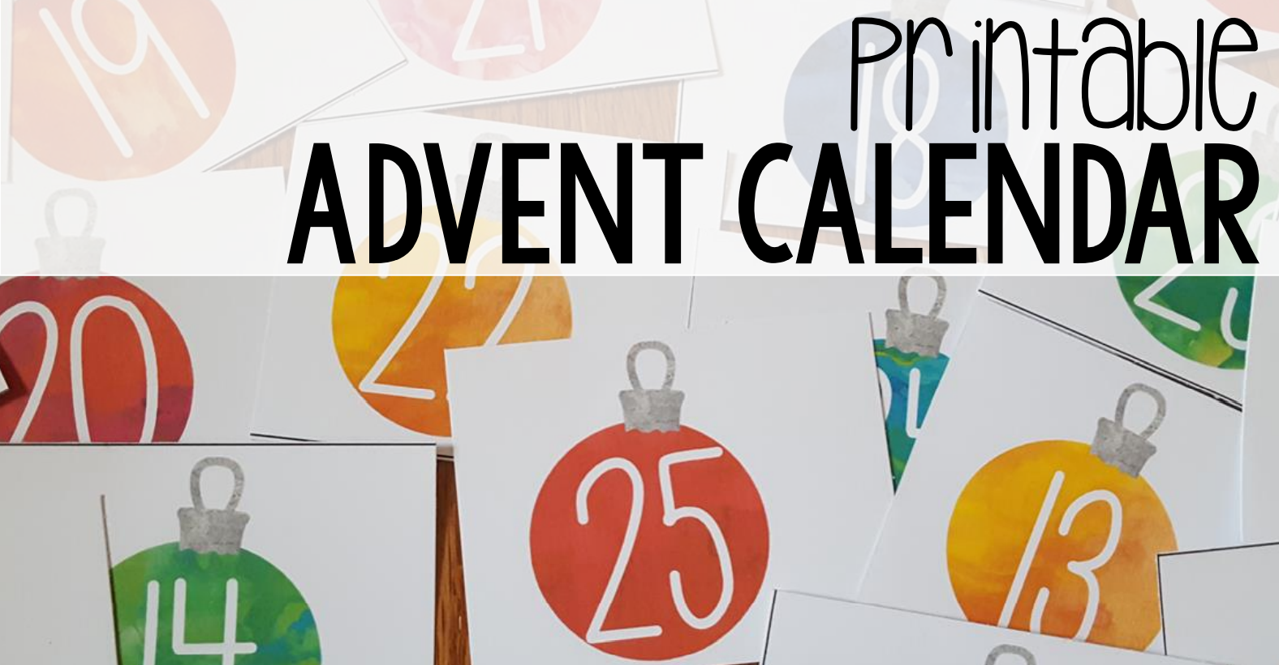

Here are some printable Christmas baubles for Advent ideas.
Why not write verses or draw pictures on the back of each one, to tell the Christmas story, and then stick them somewhere in the house, maybe on your Christmas tree, or attach them to string with clothes pegs or paperclips.
Surprise us and see where you can think of to hang or stick these!
